Job Offer/Start of Employment Letter, LMC Model Form
Helpful background information on this model may be found in the Hiring Chapter of the Human Resources Reference Manual. Please note: This notice is required by Minn. Stat. § 181.032.
This icon marks places where the city must customize the model. They offer additional provisions, optional language, or comments for your consideration. The icon, and language you do not wish to include, should be deleted from this model before use. Make other changes, as needed, to customize the model for your city.
Date the letter and print on city letterhead, ensuring it shows the legal name of the employer, the physical address of the employer’s main office and telephone number.
Note: In the event a “contract for employment” has been consummated with the employee, there is potentially an additional written notice required by Minn. Stat. § 181.55. In that case, please also see Contract Confirmation Letter.
Effective July 1, 2019, under Minn. Stat. § 181.032, at the start of employment, employers are required to provide a written notice to each employee (including temporary employees, according to the Dept. of Labor) containing the following information.
- the rate or rates of pay and basis thereof, including whether the employee is paid by the hour, shift, day, week, salary, piece, commission, or other method, and the specific application of any additional rates;
- allowances, if any, claimed pursuant to permitted meals and lodging;
- paid vacation, sick time, or other paid time-off accruals and terms of use;
- the employee's employment status and whether the employee is exempt from minimum wage, overtime, and other provisions of chapter 177, and on what basis;
- a list of deductions that may be made from the employee's pay;
- the number of days in the pay period, the regularly scheduled pay day, and the pay day on which the employee will receive the first payment of wages earned;
- the legal name of the employer and the operating name of the employer if different from the legal name;
- the physical address of the employer's main office or principal place of business, and a mailing address if different; and
- the telephone number of the employer.
The employer must keep a copy of the notice provided to the new hire and signed by each employee acknowledging receipt of the notice. The notice must be provided to each employee in English. The English version of the notice must include text provided by the commissioner that informs employees that they may request, by indicating on the form, the notice be provided in a particular language. If requested, the employer shall provide the notice in the language requested by the employee. The Commissioner shall make available to employers the text to be included in the English version of the notice required by this section and assist employers with translation of the notice in the languages requested by their employees.
While employers may choose the format they wish to use for the written notice to new hires, some cities may find it helpful to incorporate the information into their new hire letter. DLI also has a model notice cities can use: —View DLI's model notice
Place on city letterhead or include legal name of employer, mailing address, phone number, and email address.
[Date]
Juanita Doe
PO Box 1
Mosquito Heights, MN Zip
Juanita’s Email Address

Dear Juanita:
I am pleased to confirm the city of _______’s employment offer to you for the position of _______. This position is classified as [full-time/part-time/seasonal], [exempt or non-exempt (overtime eligible)] and [not/subject - choose one] to the [Minnesota/Federal - choose one or both as applicable] Minimum Wage law. [List any other exemptions from any other provisions of the state FLSA and on what basis, as applicable]. Overtime compensation will be provided at a rate of 1.5 times your hourly wage for hours worked in excess of 40 in any work week. A copy of the position description is enclosed.
In accordance with Minn. Stat. § 181.032, the city is required to include the employee's employment status and whether the employee is exempt from minimum wage, overtime provisions or other provisions of the state FLSA and on what basis.
In accordance with city policy and applicable law, the following deductions will be made from your payroll checks [choose from list and modify as applicable]:
- Insurance premiums for health, life, flex accounts, and group accident plans
- Statutorily required PERA contributions, if the position is eligible
- Federal and state withholding for taxes, social security, etc.
- Applicable union dues
- Applicable membership dues of a relief association
- Elected contributions to credit unions or other banks
- Elected Minnesota benefit association
- Elected savings plans for periods longer than 60 days
- Elected contributions to a community chest fund (i.e. charitable contributions like United Way, etc.)
In accordance Minn. Stat. § 181.032, the city is required to include a list of deductions that may be made from the employee's pay.
As permitted by city policy, you are entitled to the following allowances:
- Allowances, if any, pursuant to permitted meals and lodging

You will be expected to work eight hours/day and 40 hours/week. Your starting wage will be $_______ per hour and your first day of work will be on _______. Per our standard procedure, this offer letter is not intended, nor should it be considered as, an employment contract for a definite or indefinite period of time.
Your position is subject to a _______ day pay period and our regularly scheduled pay period is _______. Since your start date is _______, your first payday will be on _______.
In accordance with the Minnesota law change effective July 1, 2019, and in accordance with Minn. Stat. § 181.032, the City is required to include the number of days in the pay period, the regularly scheduled pay day, and the pay day on which the employee will receive the first payment of wages earned.
As a [full-time] employee, you will accrue vacation and sick leave on a [monthly] basis. Your vacation leave accrual will begin at _______ hours per month. Your monthly sick leave accrual will be _______ hours per month, of which up to 48 hours are cross designated as Earned Sick and Safe Time (ESST). A copy of the city’s personnel policy is included with this offer letter that outlines the terms of use for your accrued leave.
In the event the city and the applicant agree to some additional arrangement, for example, for a pre-arranged vacation, consider wording like: Per our earlier discussion, you are authorized to take three days of leave without pay in May for the trip you scheduled prior to this hire.
In accordance with Wage Minn. Stat. § 181.032, the city is required to include any paid vacation, sick time, or other paid time-off accruals and terms of use. Effective January 1, 2024, Minnesota law requires eligible employees to earn one hour of ESST for every 30 hours worked to a maximum of 48 hours each year unless the employer agrees to a higher amount,
In accordance with the Immigration and Reform and Control Act of 1986, you must provide appropriate documentation to establish identity and eligibility for employment on your first day of work. I’ve included a copy of the Department of Homeland Security’s list of acceptable documents for your review. Please complete the highlighted section of the I-9 form and bring this completed document with you on your first day of employment.
Please report to _______ on the _______ at _______ a.m. and ask for _______. Do not hesitate to call if you have any questions prior to that time. We are pleased that you will be joining our staff and look forward to working with you in this position. If you have any questions prior to your start date, please contact your supervisor, _______, at _______, or me at _______.
Sincerely,

_______
City Administrator

cc: personnel file
By signing below, I acknowledge I have received the foregoing information regarding my employment offer and related pay and benefits provided in accordance with Minnesota Statutes §181.032. I understand that [city name] employment is not for a specific term and can be terminated by me or by the [city name] at any time for any reason, with or without cause.
_____________________________ ___________________________
Name Date

In accordance with the Minnesota law change effective July 1, 2019, the employer must keep a copy of the notice provided to the new hire and signed by each employee acknowledging receipt Employees have a right to receive this notice in a language other than English but only for those languages for which the DOES Office of Wage-Hour has developed its own dual-language notice.
Once signed to indicate you’ll be joining us, email to [City contact email address] or send to our confidential fax # [fax number].

This document contains important information about your employment. Check the box at the left to receive this information in this language.

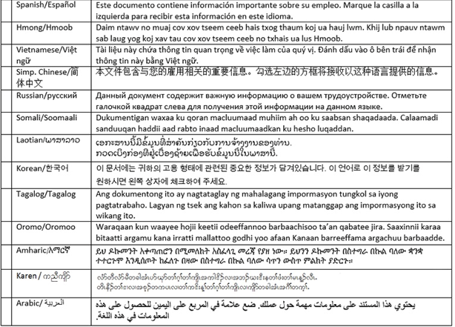
In accordance with Minnesota’s employee wage notice requirements, , the English version of the notice must include text provided by the commissioner that informs employees they may request, by indicating in the table above, the notice be provided in a particular language. If requested, the employer shall provide the notice in the language requested by the employee.

