Contract Confirmation Letter, LMC Model Form

Helpful background information on this model may be found in the Hiring Chapter of the Human Resources Reference Manual. Please note: This is a separate requirement from the start of employment notice of Minn. Stat. § 181.032. This notice is required by Minn. Stat. § 181.55, but only in the unusual circumstance a “contract of employment” is consummated between an employer and employee for work in this state or for work to be performed in another state for an employer localized in this state. Under Minn. Stat. § 181.57, it is not required for temporary employees or does it apply to employers with fewer than 10 employees.

This icon marks places where the city must customize the model. They offer additional provisions, optional language, or comments for your consideration. The icon, and language you do not wish to include, should be deleted from this model before use. Make other changes, as needed, to customize the model for your city.

Date the letter and print on city letterhead.

Employers with 10 or more are required to give employees (with the exception of “casual” temporary employees) a written, signed “agreement of hire.” In accordance with Minnesota Statutes 181.55, the letter must contain:
- Date of the agreement
- Hire date
- Rate of pay (for exempt quote per pay period rate; for non-exempt quote hourly rate)
- Hours in a regular work day
- Whether the employee is eligible for overtime and if so at what rate
- Statement of any job duties or responsibilities which, if not performed properly, can result in deductions from the employee’s paycheck and the terms of those deductions.

Effective July 1, 2019, under Minn. Stat. § 181.032, at the start of employment, employers are required to provide a written notice to each employee (including temporary employees, according to the Dept. of Labor) containing the following information.
- the rate or rates of pay and basis thereof, including whether the employee is paid by the hour, shift, day, week, salary, piece, commission, or other method, and the specific application of any additional rates;
- allowances, if any, claimed pursuant to permitted meals and lodging;
- paid vacation, sick time, or other paid time-off accruals and terms of use;
- the employee's employment status and whether the employee is exempt from minimum wage, overtime, and other provisions of chapter 177, and on what basis;
- a list of deductions that may be made from the employee's pay;
- the number of days in the pay period, the regularly scheduled pay day, and the pay day on which the employee will receive the first payment of wages earned;
- the legal name of the employer and the operating name of the employer if different from the legal name;
- the physical address of the employer's main office or principal place of business, and a mailing address if different; and
- the telephone number of the employer.
The employer must keep a copy of the notice provided to the new hire and signed by each employee acknowledging receipt of the notice. The notice must be provided to each employee in English. The English version of the notice must include text provided by the commissioner that informs employees that they may request, by indicating on the form, the notice be provided in a particular language. If requested, the employer shall provide the notice in the language requested by the employee. DLI shall make available to employers the text to be included in the English version of the notice required and assist employers with translation of the notice in the languages requested by their employees.
While employers may choose the format they wish to use for the written notice to new hires, some cities may find it helpful to incorporate the information into their new hire letter. DLI also has a model notice cities can use: —View DLI's model notice

[Date]

Juanita Doe
PO Box 1
Mosquito Heights, MN

Dear Juanita:

I am pleased to confirm the City of _______’s employment relationship with you for the position of _______. This position is classified as full-time, non-exempt (overtime eligible) and [not/subject - choose one] to the [Minnesota/Federal - choose one or both as applicable] Minimum Wage law. [List any other exemptions from any other provisions of the state FLSA and on what basis, as applicable]. Overtime compensation will be provided at a rate of 1.5 times your hourly wage for hours worked in excess of 40 in any work week. A copy of the position description is enclosed.

You will be expected to work eight hours/day and 40 hours/week. Your starting wage will be $_______per hour and your first day of work will be on _______. Please note, as the City has consummated a contract for employment with you, this serves as “written notice” required by Minnesota Statutes, section 181.55.

Your position is subject to a _______ day pay period and our regularly scheduled pay period is _______. Since your start date is _______, your first pay day will be on _______.
As a full-time employee, you will accrue vacation and sick leave on a monthly basis. Your vacation leave accrual will begin at _______ hours per month. Your monthly sick leave accrual will be _______ hours per month.

In the event the city and the applicant agree to some additional arrangement, for example, for a pre-arranged vacation, consider wording like: Per our earlier discussion, you are authorized to take three days of leave without pay in May for the trip you scheduled prior to this hire.

In accordance with the Immigration and Reform and Control Act of 1986, you must provide appropriate documentation to establish identity and eligibility for employment on your first day of work. I’ve included a copy of the Department of Homeland Security’s list of acceptable documents for your review. Please complete the highlighted section of the I-9 form and bring this completed document with you on your first day of employment.

Please report to _______ on the_______ at _______ a.m. and ask for _______. Do not hesitate to call if you have any questions prior to that time. We are pleased that you will be joining our staff and look forward to working with you in this position. If you have any questions prior to your start date, please contact your supervisor, _______ , at _______ , or me at _______ .

Sincerely,

_______
City Administrator

cc: Personnel File

By signing below, I acknowledge I have received the foregoing information regarding my contract offer and related pay and benefits provided in accordance with Minnesota Statutes, section 181.55.
_____________________________ ___________________________
Name Date

This document contains important information about your employment arrangement. Check the box at the left to receive this information in this language.

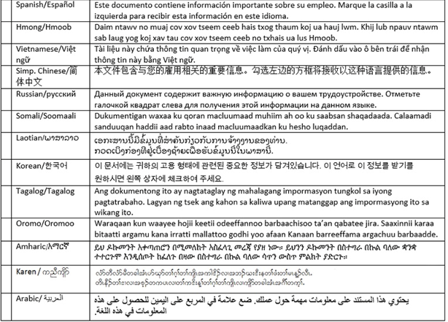
In accordance with the July 1, 2019 law change, the English version of the notice must include text provided by the commissioner that informs employees that they may request, by indicating on the form, the notice be provided in a particular language. If requested, the employer shall provide the notice in the language requested by the employee.

